LOGIN (1)
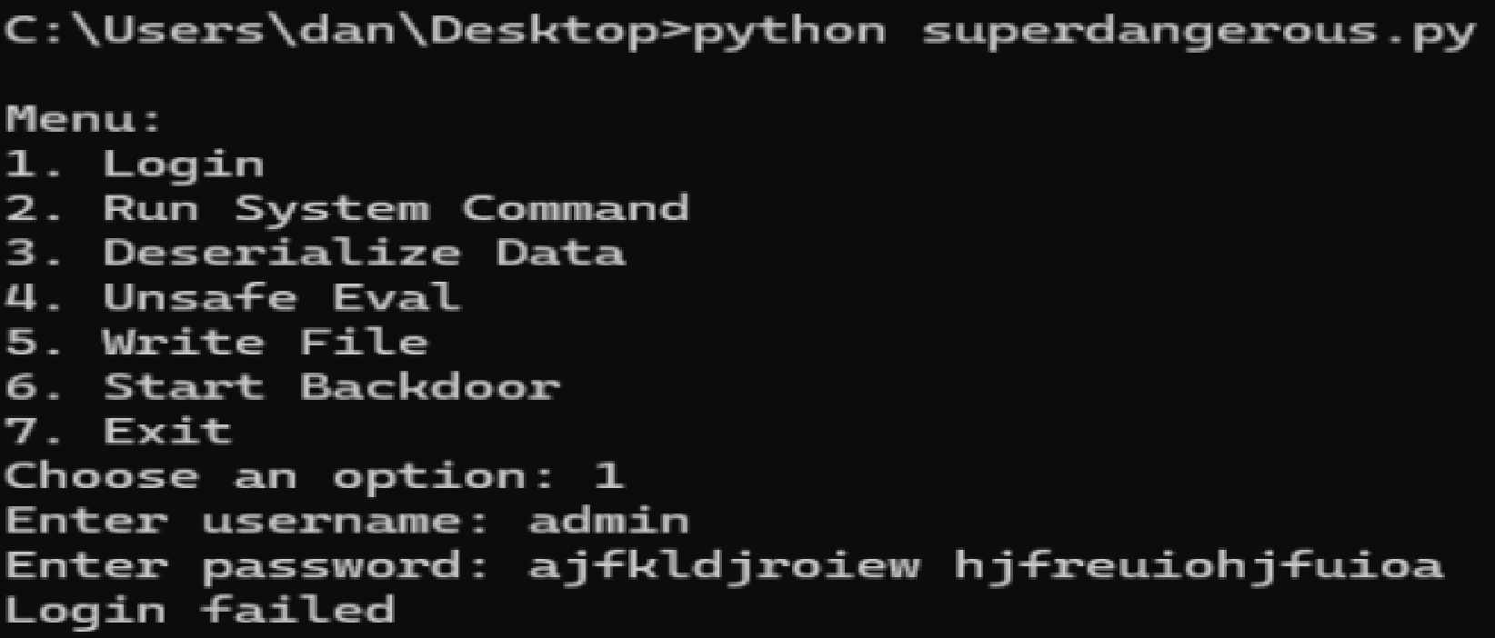
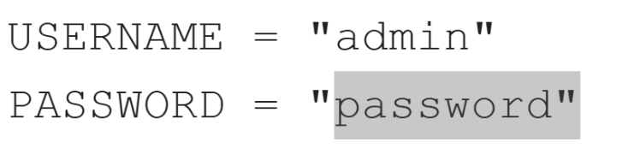
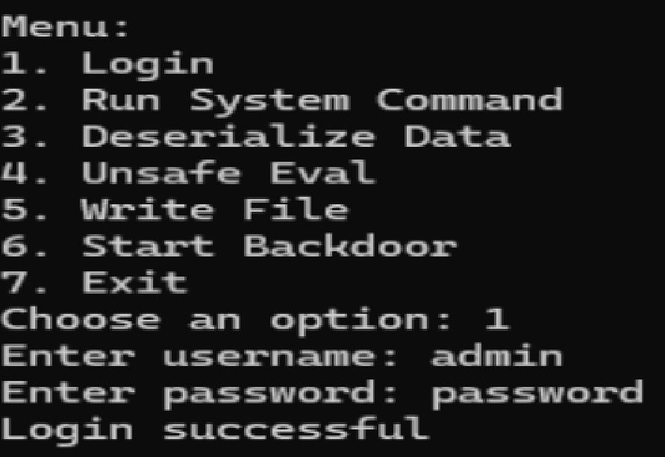
The login system stores the username and password directly in the code. I tested it by typing a wrong password and it failed, then I typed the correct password and it worked. Since the login info is written in the code, anyone can see it and use it to log in. This makes it not secure because there is no real protection for the login system.
Run system Command (2)
The run system command option is not safe because it lets the user type any command and the program runs it. The code uses os.system(user_input) which means it takes whatever the user types and runs it directly with no checking or filtering. I tested this by typing commands like "whoami" and "dir" and it executed them. This is bad because someone could run harmful commands, delete files, or access important information. Since there are no limits on what can be entered, it basically gives full control of the system to the user.
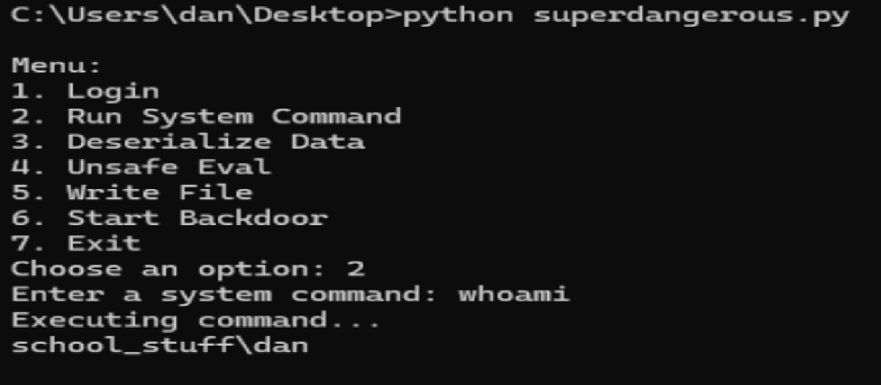
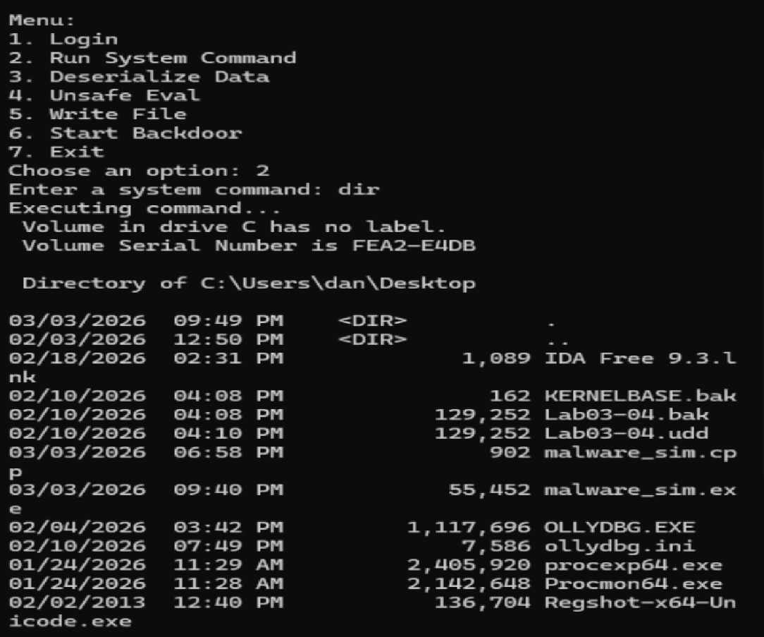

Deserialize Data (3)
The deserialize data feature is not safe because it uses pickle.loads() directly on user input without checking it first. The code takes whatever the user types, converts it into bytes and then tries to deserialize it. I tested this by entering "hello" and the program crashed which shows it still tries to process any input even if it is not valid.
This is dangerous because pickle can run malicious code, not just load data. Since there is no validation or filtering, an attacker could send specially crafted input and execute code on the system.
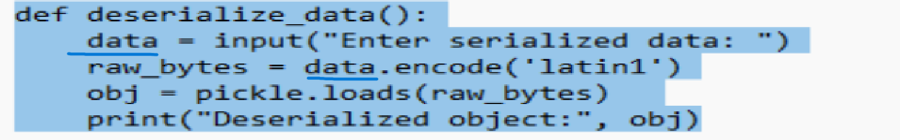
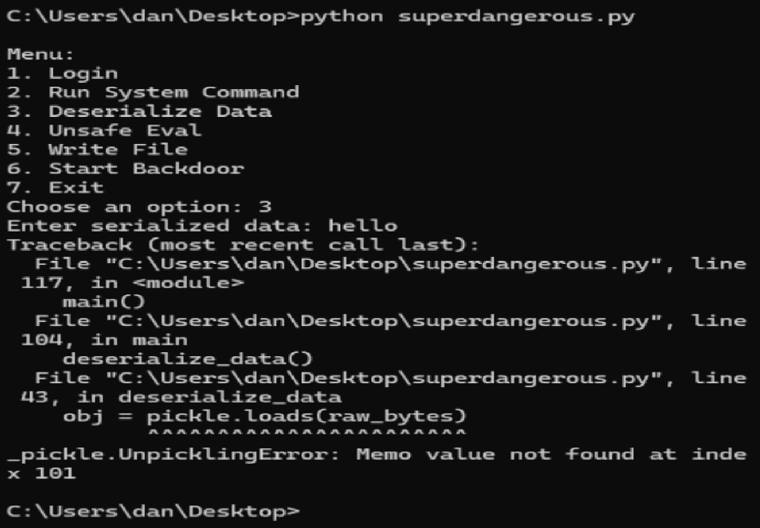

Unsafe eval (4)
The unsafe eval feature is not safe because it uses eval() directly on user input. This means whatever the user types is treated as Python code and gets executed. I tested it with a normal math expression like "2+2" and it returned 4, which shows it works as expected. Then I tested it with __import__('os').system('whoami') and it actually ran a system command and showed my username.
This is dangerous because it allows the user to run any Python code, including system commands. There is no validation or restriction, so an attacker could run harmful commands, access files, or take control of the system.
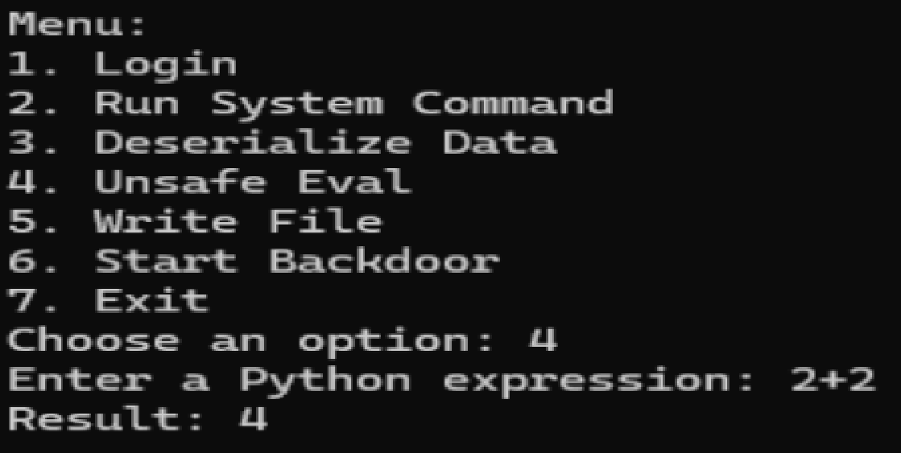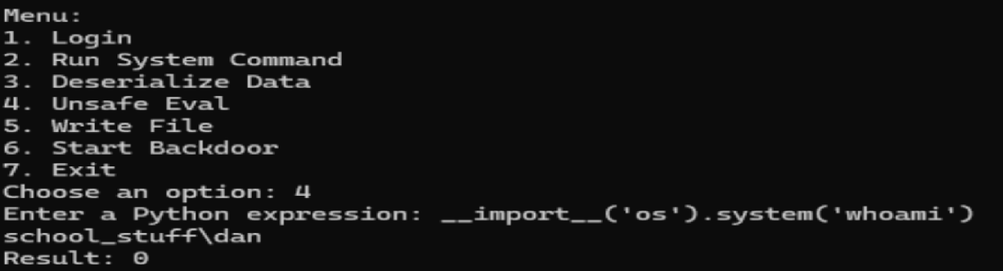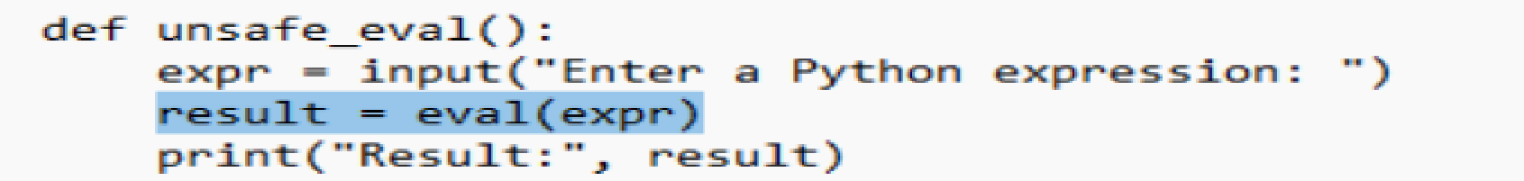

Write file (5)
The write file function is not safe because it takes the filename and content directly from the user and writes it to the system without any checks. The code uses open(filename, 'w') and f.write(content), which means whatever the user types gets saved exactly as is.
I tested this by creating a file called "ha.py" and putting print("hello world") inside it, and the program wrote the file successfully. This shows that the user can create any file and put anything in it.This is dangerous because a user could create harmful scripts, overwrite important files, or place files in sensitive locations. Since there is no validation or restriction, it gives full control over file creation on the system.
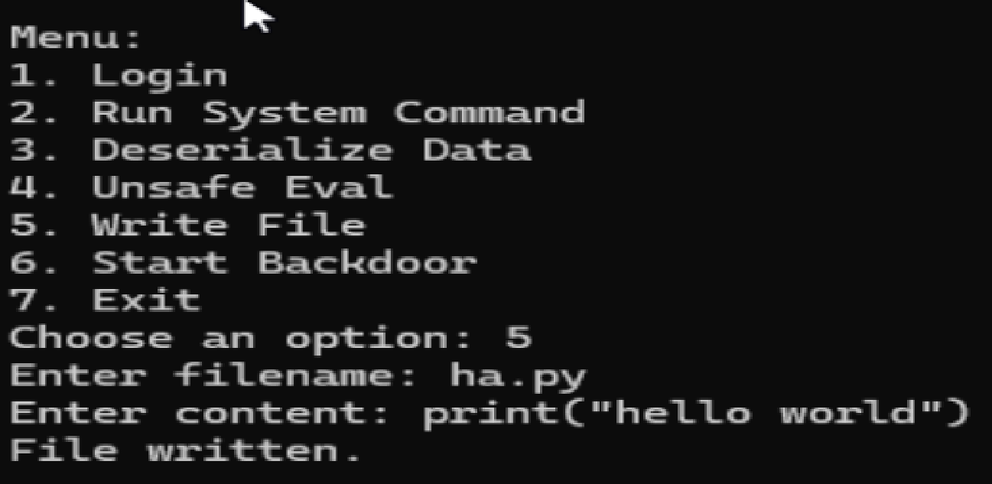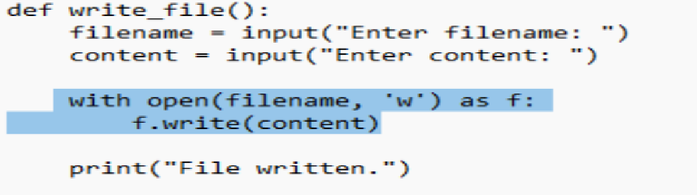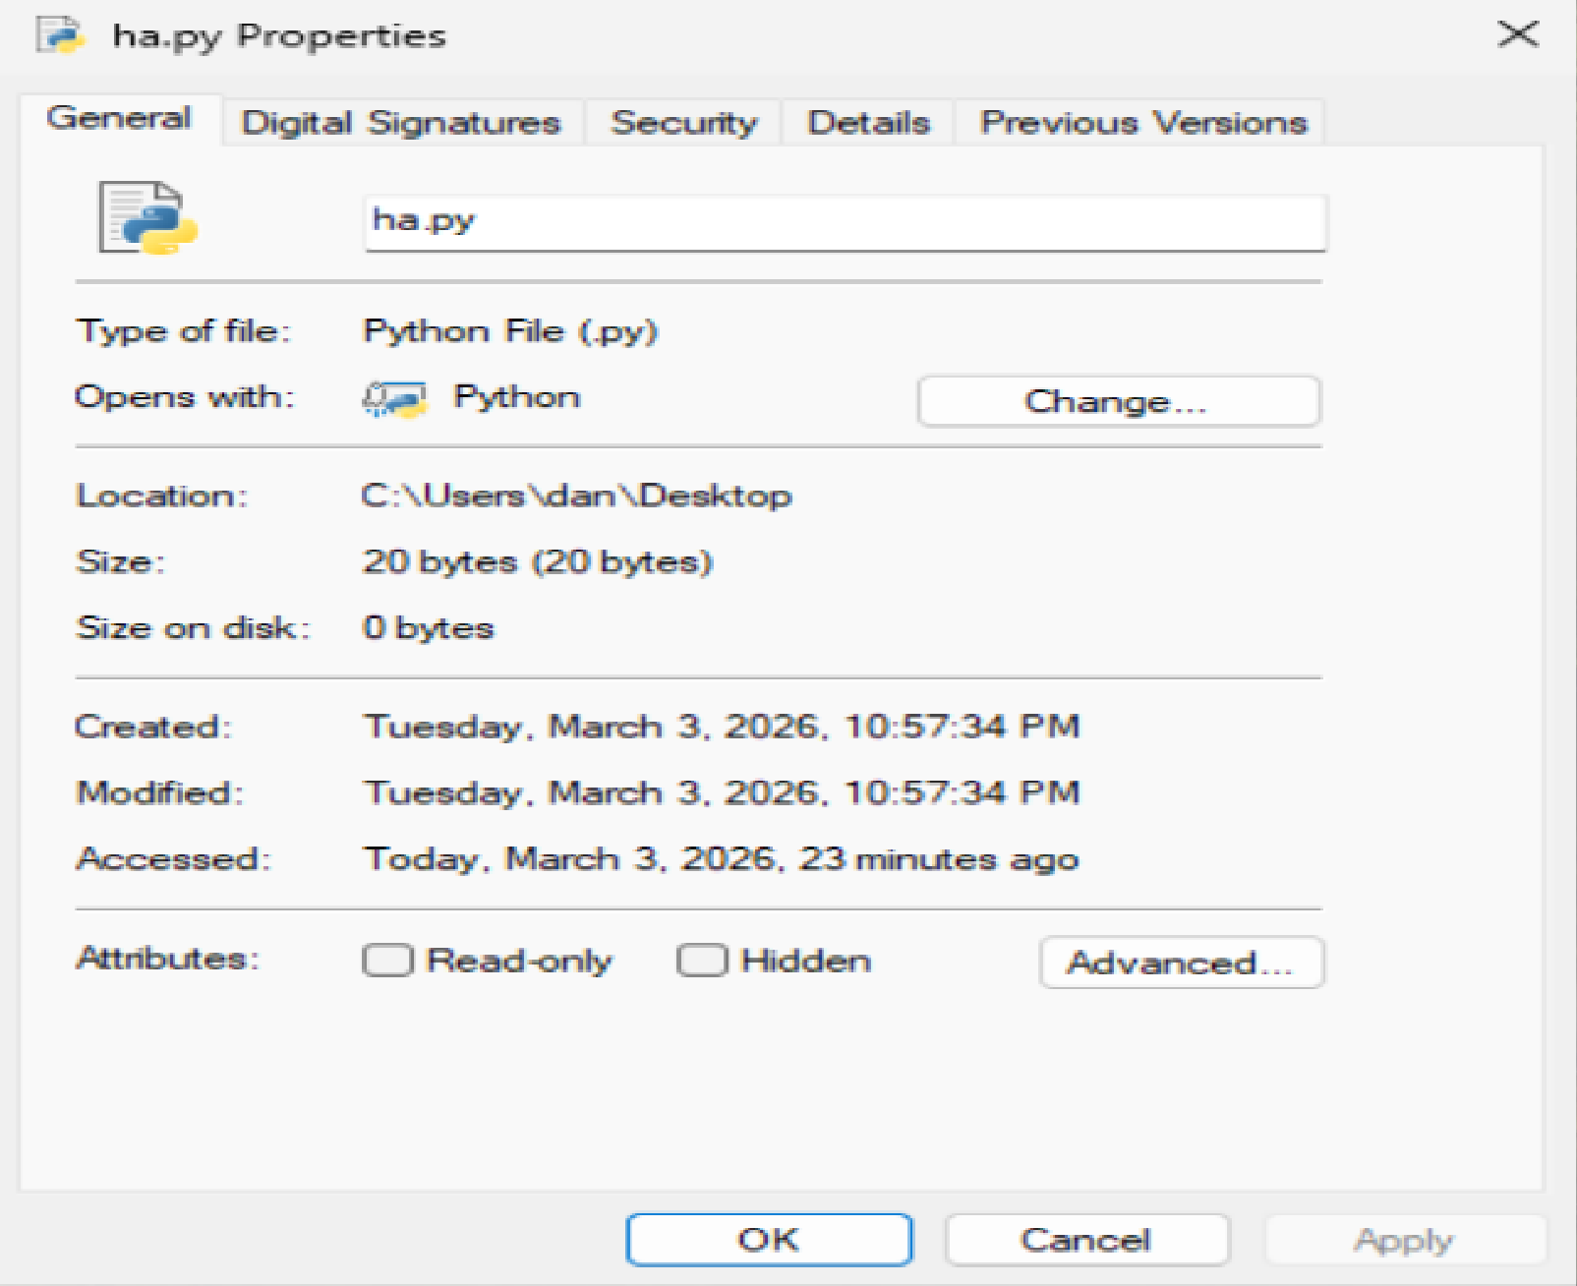
Start backdoor (6)
The backdoor program that opens a port and waits for someone to connect to it. In the first picture the program says “Backdoor listening on port 9999” which means it is running and waiting for a connection.
In the second picture the command netstat -an | findstr 9999 shows that port 9999 is in a LISTENING state. This proves the backdoor is active and waiting for someone to connect to it.
The third picture shows the code that makes this happen. The program creates a socket, binds it to port 9999 and starts listening. The line conn, addr = s.accept() is important because it pauses the program and waits until a connection is made. After that, the program goes into a loop where it just sits and waits for commands from whoever connects, then runs those commands and sends the results back.
The last picture from Wireshark shows the network traffic for port 9999. You can see TCP packets like SYN and ACK, which show that a connection is trying to be made.
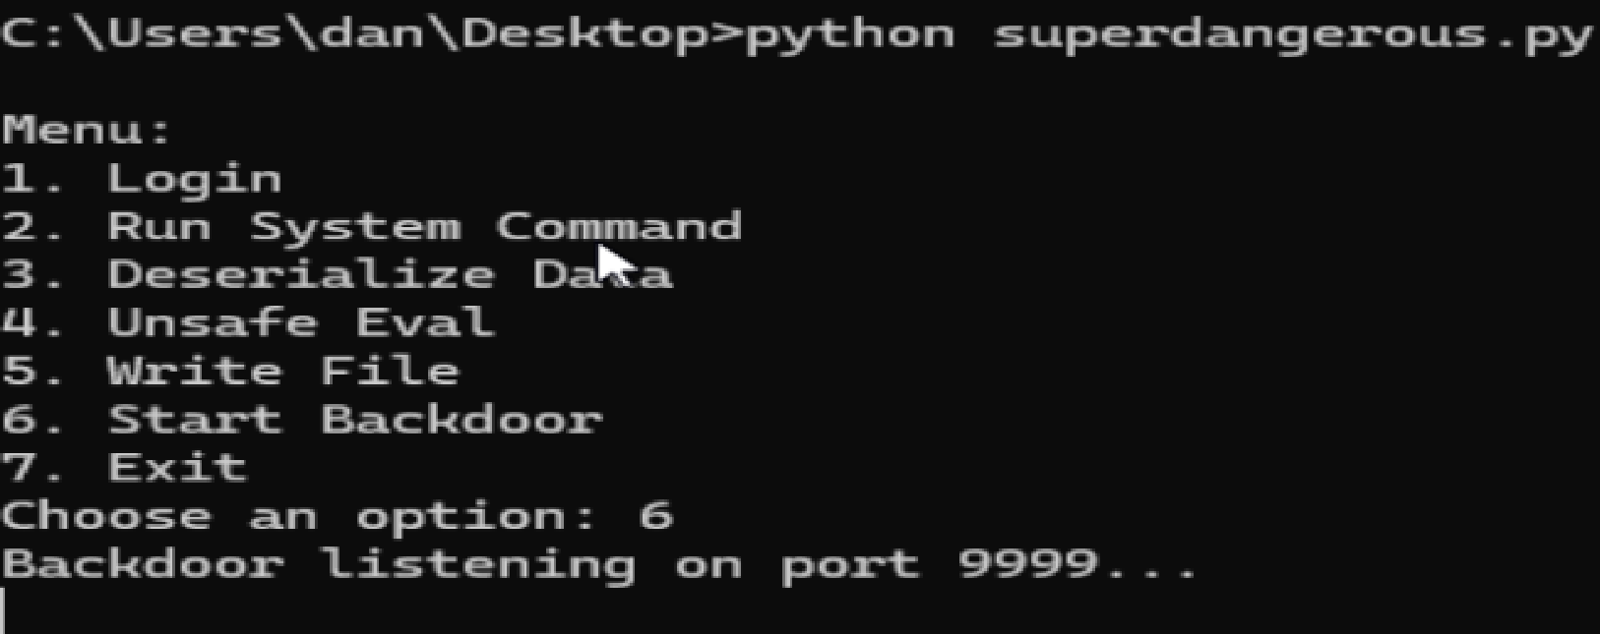
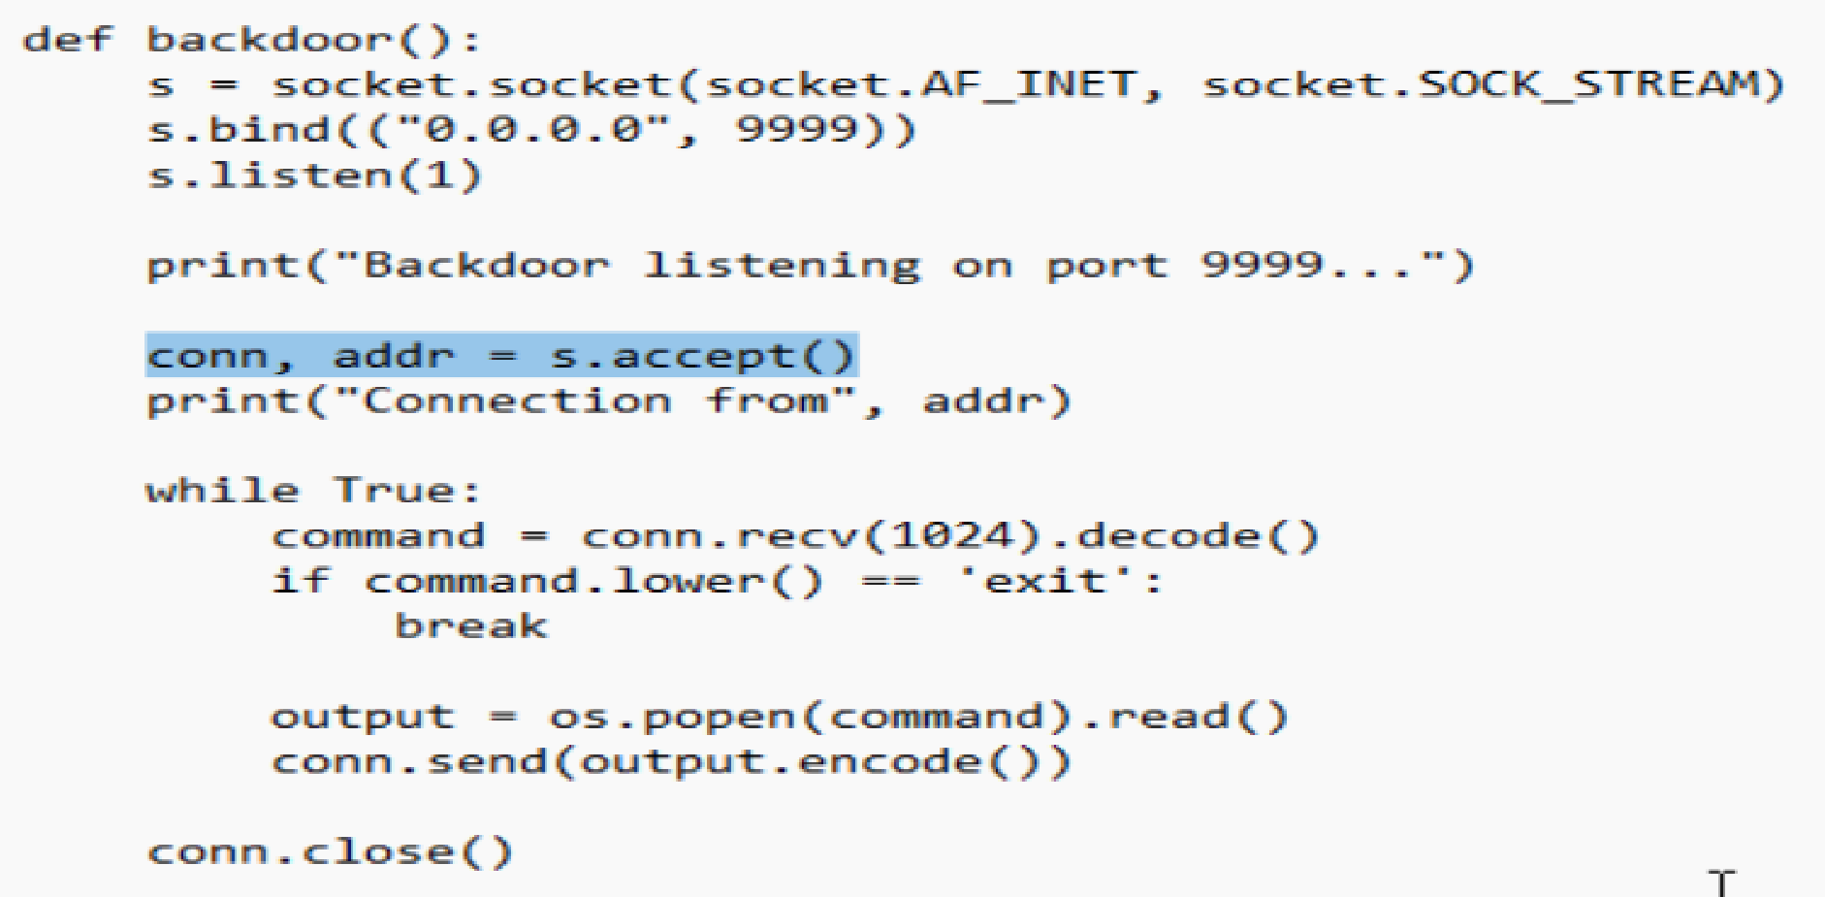 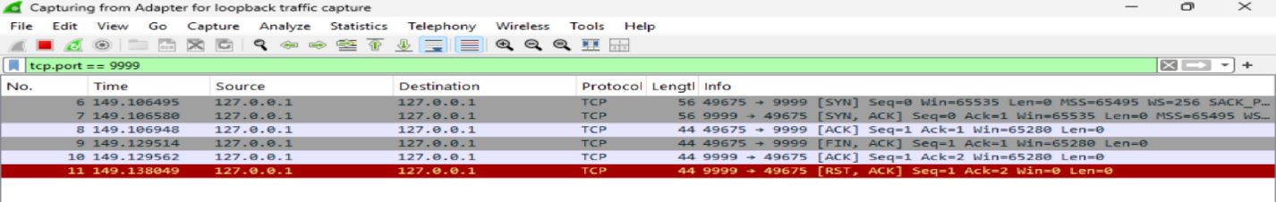
No one could actually connect to me ( vm/ no internet):


